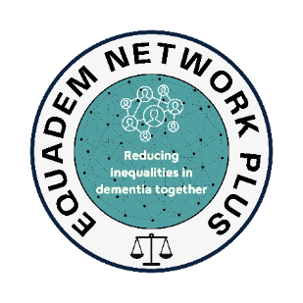
ESRC Equalities in Dementia (EquaDem) Network Plus
Research Internships Application Form

Please read the supporting information before completing this form.
Return forms to Equademnetworkplus@liverpool.ac.uk by 5pm, 13th June 2025
Applicant
Name:
Email: | Telephone:
Current employer:

Work address:

Position / role:

Full-time ☐  Part-time ☐  If part time, number of hours worked per week = |  | Band/Grade:
Please summarise your main responsibilities: (300 words)

Have you previously been supported by one of the CLAHRC / ARC NWC Programmes? If yes, please name the internship or postgraduate course completed below:

Applicant’s personal statement
Please provide a personal statement. Include a brief description of your research experience to date and the reasons why you wish to apply for an Internship. (500 words)

Title of proposed research project:

Please describe your research project idea: What is the background? Why is it important from an organisational and patient / service user perspective? How would you carry it out? How would you involve patients and the public in the project? (500 words)

PUBLIC INVOLVEMENT
Please state how you will involve members of the public in your internship project (300 words max)
HOW THE PROJECT WILL ADDRESS HEALTH INEQUALITIES
Please state how your proposed research will aim to provide solutions to health inequalities. See the Health Inequalities Assessment Tool (HIAT) https://forequity.uk/hiat/: (500 words)

BUDGET
You can apply for up to £5000 (80% funded by EquaDem, 20% funded by your host organisation) salary backfill for this internship. You can also apply for up to £500 (80% funded by EquaDem, 20% funded by your host organisation) in research costs to support the delivery of your project. This may involve public involvement fees, transcription costs, travel, co-production, and other research-related costs. Detail your budget request below:

supervision for your internship
Have you discussed your project with two potential supervisors at one/two of the EquaDem universities?
If yes, please provide their name and email:

APPLICANT TO COMPLETE
I confirm that I will be able to commit up to 1 day/week for the period of this internship ☐

Name of applicant |  | Date
When you have completed this form, send it (as an attachment with an explanatory email) to your line manager who must add their statement and name below and send on to the senior manager (Trust R&D manager for NHS employees)

Line manager to complete
Please provide a statement on the applicant’s suitability for this internship programme, their research career to date, and how the proposed research project idea aligns with your organisational priorities: (300 words)

I have discussed this with the applicant and I am aware that should the applicant be successful there will be a maximum of £5000 funding available for salary backfill.

I support this EquaDem internship application.
Name of line manager | Email address | Date
Line manager to send as email attachment to senior manager (Trust R&D manager for NHS employees) with a copy to the applicant

Senior MANAGER/ Trust R&D manager (for NHS employees) to complete
- I am aware that should the applicant be successful there will be a maximum of £5000 funding available for salary backfill (80% FUNDED BY eQUADEM, 20% funded by your host organisation).
- I support this EquaDem internship application.
Name of Senior Manager/Trust R&D Manager | Email address | Date
Senior manager / Trust R&D manager to save as pdf and send a copy of the final form as email attachment to Equademnetworkplus@liverpool.ac.uk, the applicant and their line manager

